**PROJECT REPORT OF DEVELOPER BASIC SKILLS**

VO HO PHI LONG

Zulfiqar Malik

Oulu University of Applied Sciences

**CONTENTS**

**1 INTRODUCTION** 3

**2 THE WORK ENVIRONMENT**  3

**3 UI DESIGN MATERIAL**  3

3.1 Design of Menu bar 3

3.2 Design of Number system conversions 4

3.3 Design of Number system outputs 4

3.4 Design of Combinatorics calculator 5

3.5 Design of Truth Tables 5

3.6 Design of Random value tester 6

3.7 Design of Trigonometry Calculator 6

**4 RESULTS**  7

4.1 Menu bar 7

4.2 Number system conversions 8

4.3 Number system outputs 8

4.4 Combinatorics calculator 9

4.5 Truth tables 9

4.6 Random number tester 10

4.7 Trigonometry calculator 10

**1 INTRODUCTION**

This is the report of Developer Basic Skills course project. The project objective is to make a website which provides 6 different mathematics tools.

The website site we made has following tools: Number system conversions, Number system outputs, Combinatorics calculator, Truth tables, Random value tester, and Trigonometry calculator.

**2 THE WORK ENVIRONMENT**

We worked at school and at home.

**3 UI DESIGN MATERIAL**

3.1 Design of Menu bar

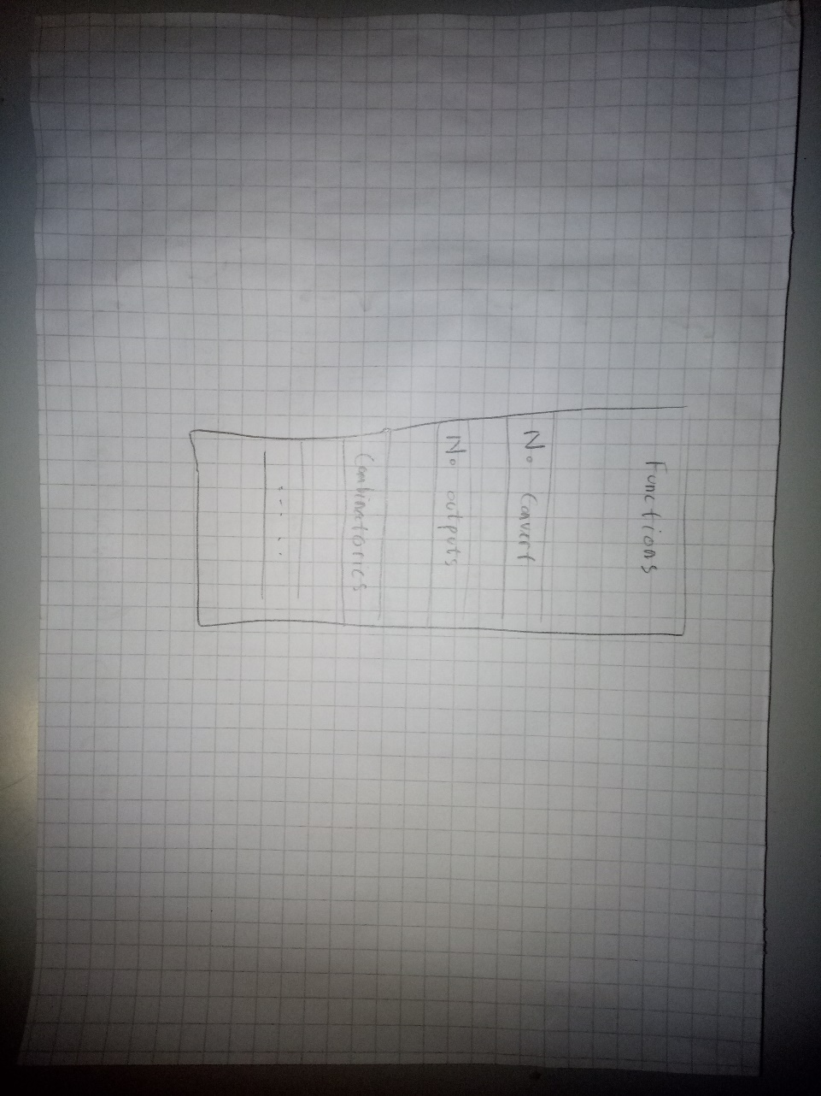

3.2 Design of Number system conversions

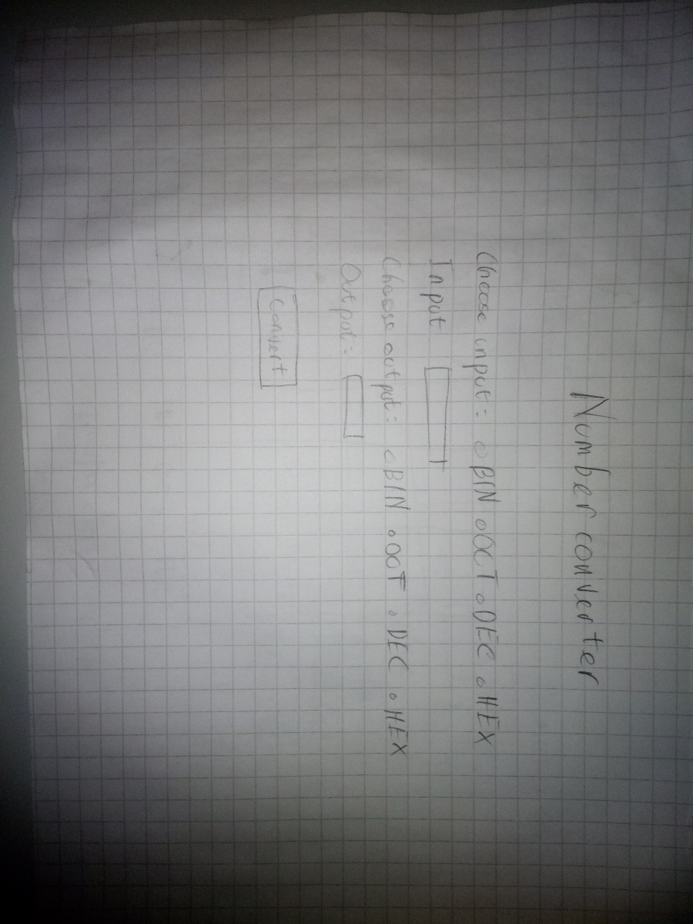

3.3 Design of Number system outputs

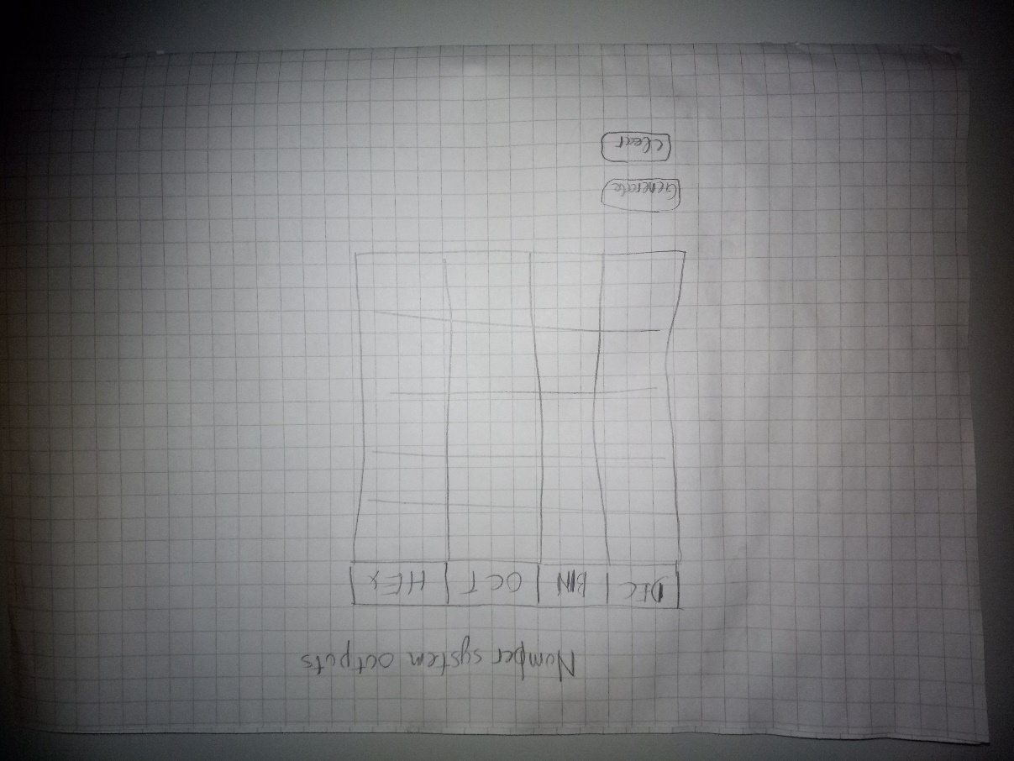

3.4 Design of Combinatorics calculator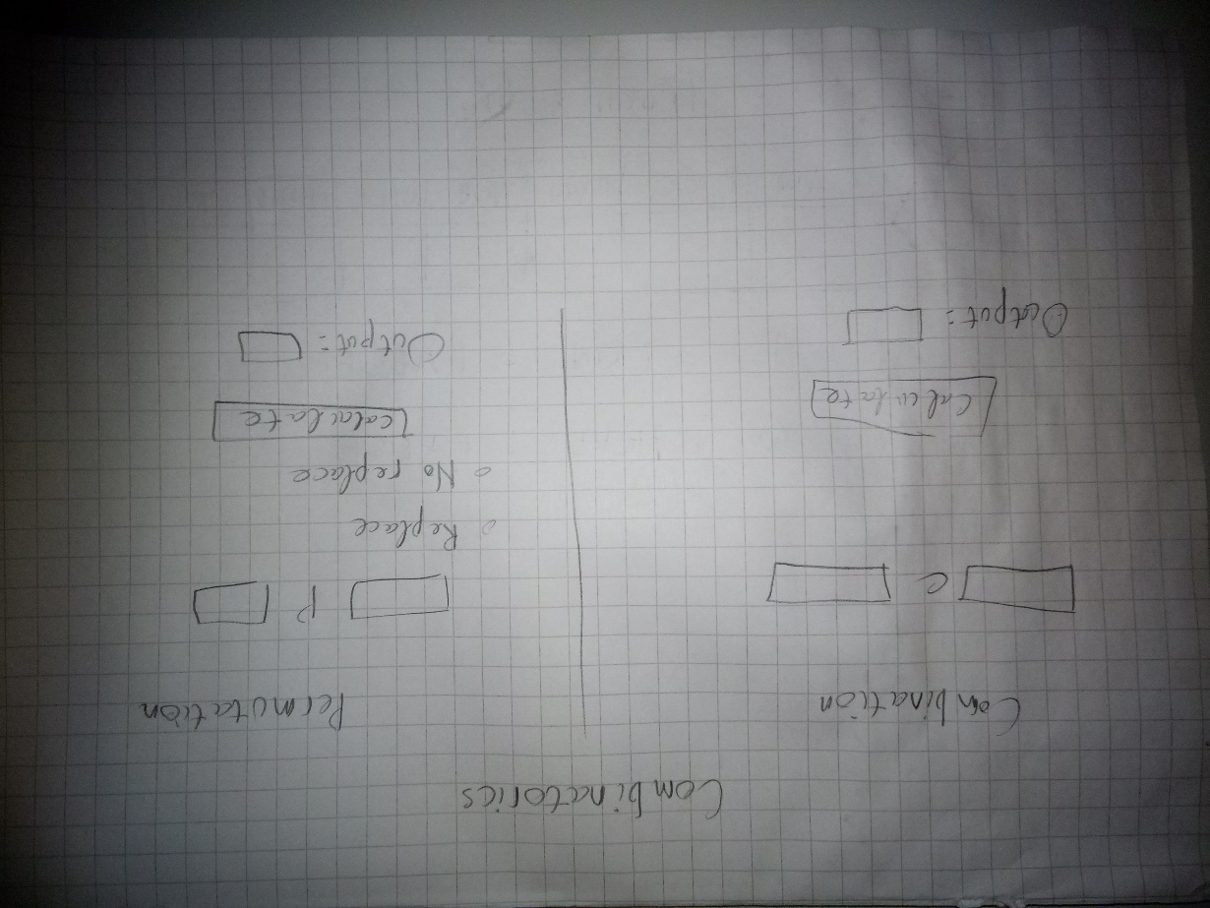

3.5 Design of Truth Tables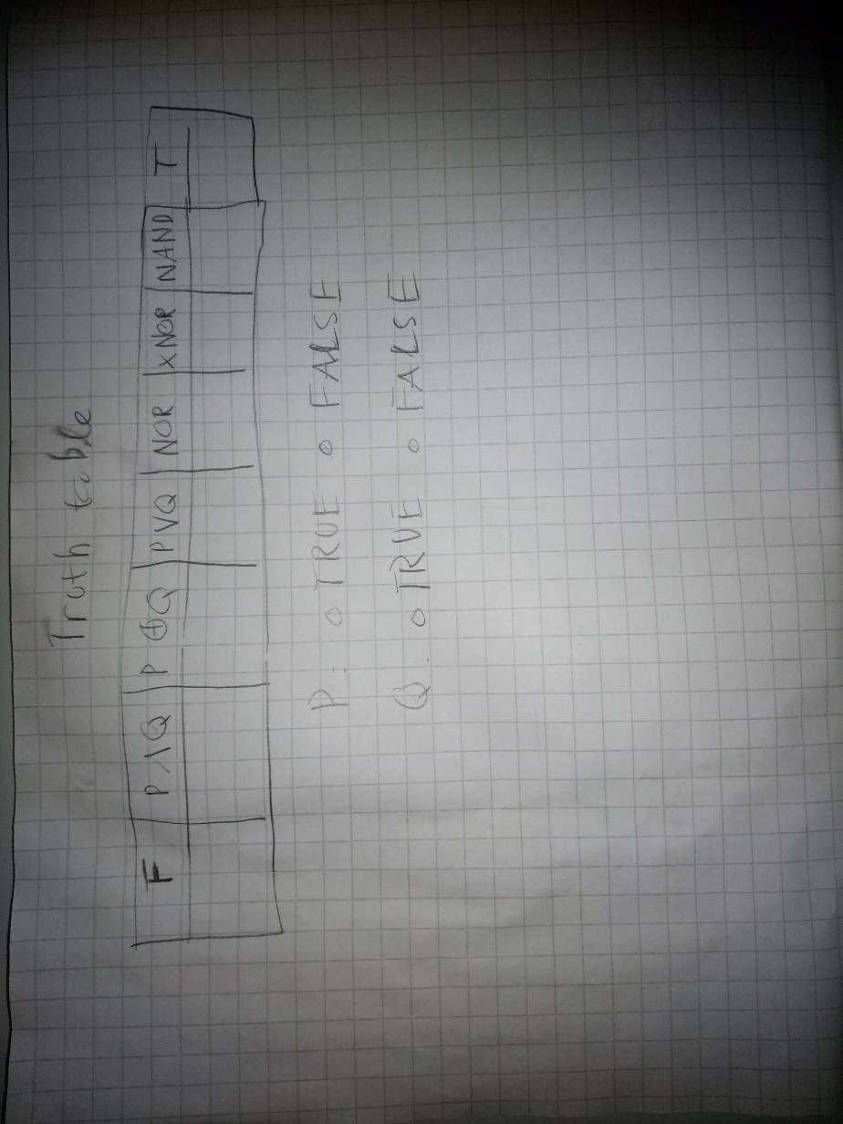

3.6 Design of Random value tester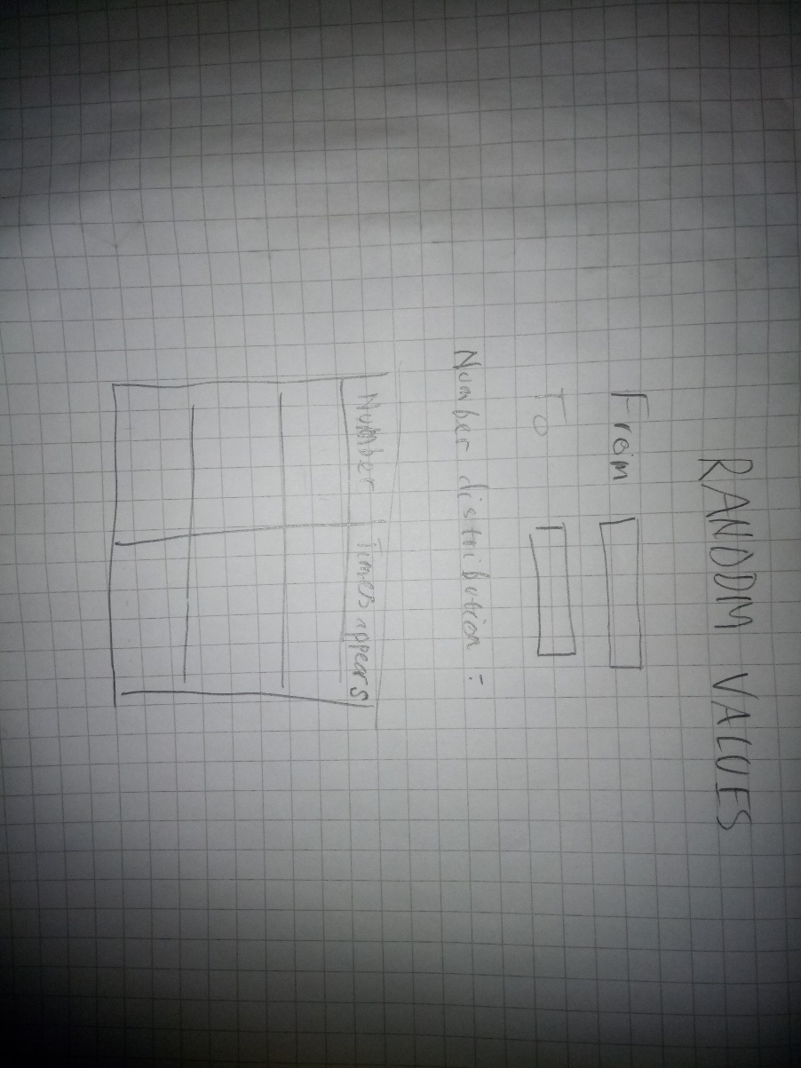

3.7 Design of Trigonometry Calculator 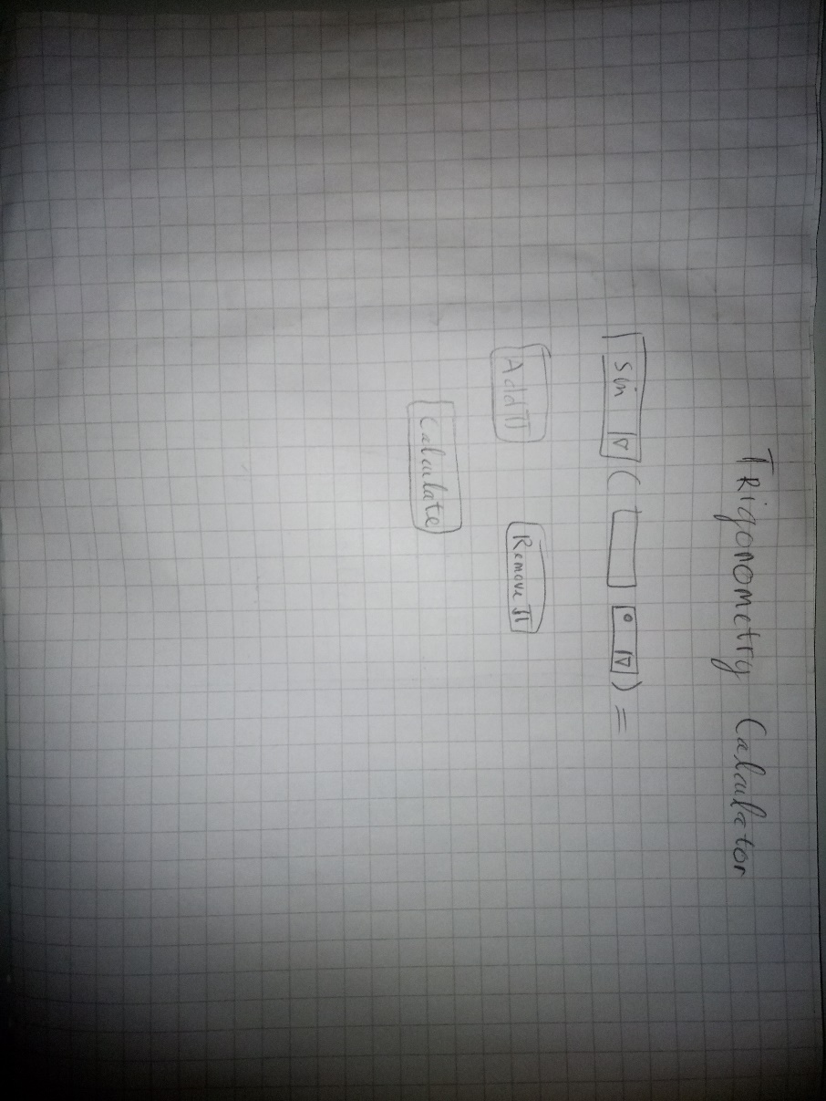

**4 RESULTS**

4.1 Menu bar

The Menu bar is used to navigate between functions of the website. Move to another function by clicking in that function. No error found.

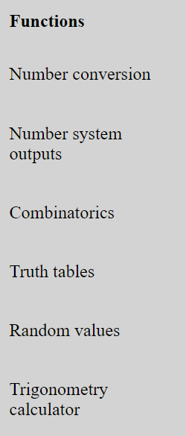

4.2 Number system conversions

The Number system conversions are used to convert a number from one system to another. Simply click to chose input and output type, then click convert button to have to result. It can also convert negative numbers. No error found.

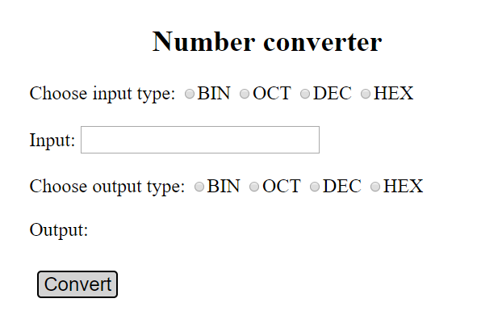

4.3 Number system outputs

The Number system outputs shows numbers from 1 to 50 in binary, octal and hexadecimal systems. Click Generate button to crate the table and Clear button to clear the table. Error: Every time clicking Generate button, the website creates another battle below the current table.

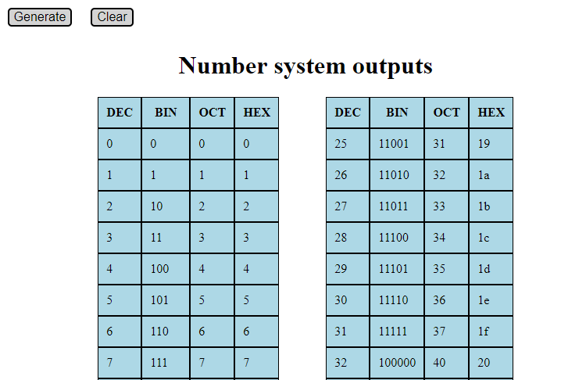

4.4 Combinatorics calculator

The Combinatorics calculator is used to calculate Combinations and Permutations. Input numbers and click calculate on Combination side to calculate combination. Permutation offers the selections of Replace and No replace, which yields different results. Operating Permutation side is similar to Combination. No error found.

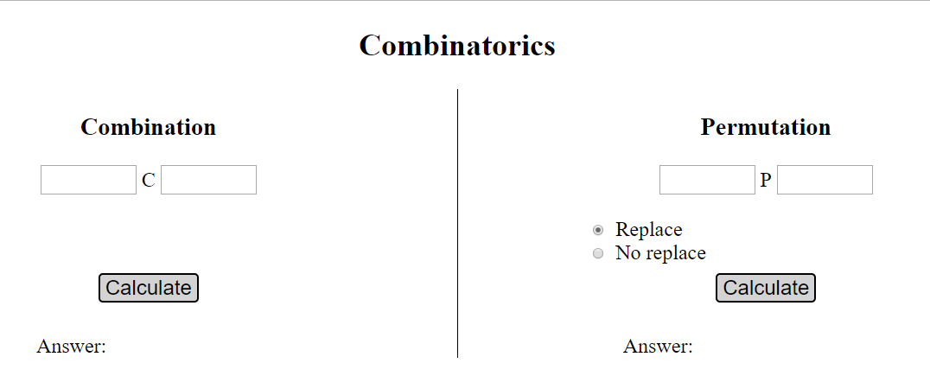

4.5 Truth tables

The Truth tables shows results of different logical connections between P and Q. Choose the value of P and Q by clicking circles then click Generate button to show the results. No error found.

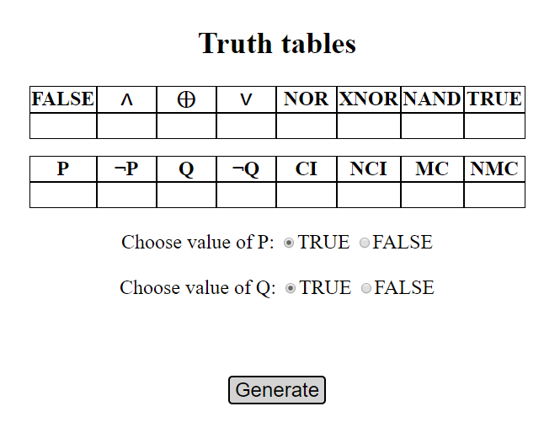

4.6 Random number tester

The Random number tester is used to check random numbers distribution. Input numbers to From and To to specify the range and click Test button to show result. It will show numbers distribution and how many times each number appears from small to big order. Error: if number in From is bigger than number in To, the program won’t work.

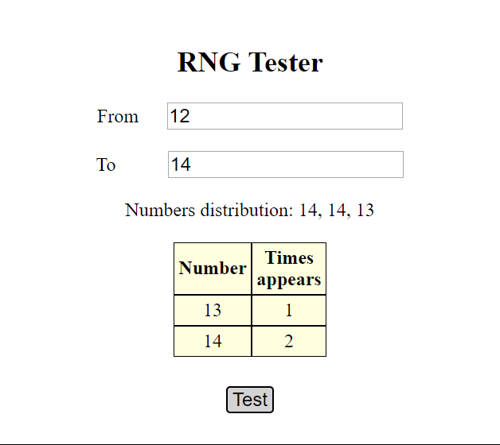

4.7 Trigonometry calculator

The Trigonometry calculator is used to calculate trigonometry values. Select sin/cos/tan/cot, input value, select degree/radian and click calculate to show result. Click Add π or Remove π to add/remove π in input value. Click Round to 2 decimal places button to round to two decimal places. No error found.

